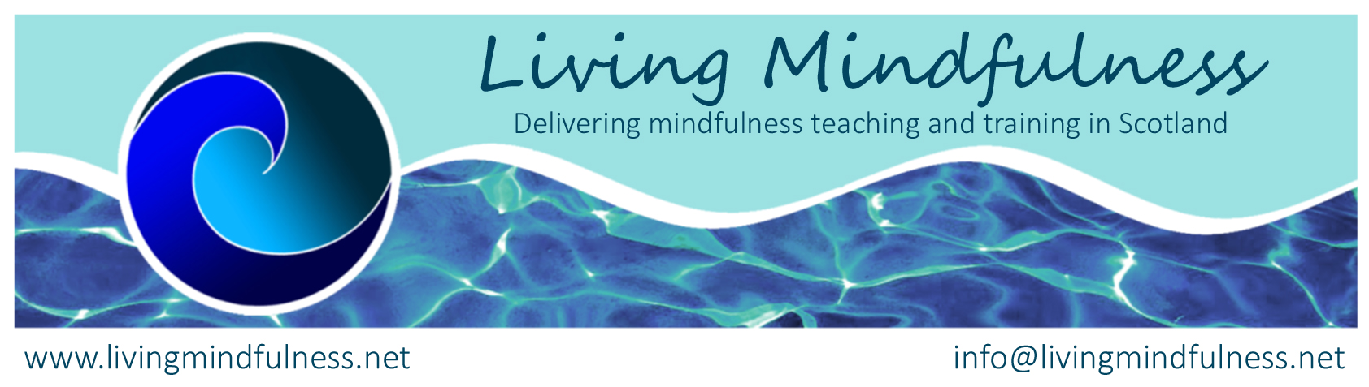

Mindfulness Teacher Training Course 2023

facilitated by Dr Charlotte Procter and Ratnadevi (Dr Luise Holtbernd)
hybrid format, in-person in Glasgow and online
This year-long training course is for people who want to develop their understanding and teaching skills in mindfulness based cognitive therapy / stress reduction (MBCT/MBSR), with view to delivering programmes or integrating the approach into their work. Participants will have completed an 8 week MBCT, MBSR or our Living Mindfulness course, have had a regular daily meditation practice for at least a year and attended at least one retreat.
The course meets the Good Practice Guidelines and requirements for the BAMBA (British Association of Mindfulness-Based Approaches) teachers register. Ratnadevi and Charlotte are both on the register themselves. The assessment will use the MBI-TAC criteria as developed by the Bangor Centre for Mindfulness and at completion a certificate will be issued.
Initially, trainees will study ‘Mindfulness-based cognitive therapy for depression’ by Teasdale, Williams and Segal, as a foundational training. Then they will become familiar with the 8 week Living Mindfulness course, which is based on MBCT, MBSR and MBCT for Life. Whilst following the tried and tested structure of those approaches, in the Living Mindfulness programme we place a stronger emphasis on embodiment through mindful movement, the development of nourishing mental states such as gratitude and throughout the whole course runs a thread of awareness of needs and values. We encourage an attitude of ‘engaged mindfulness’, placing our personal training in the wider context of the pressing topics of our world, such as climate change.
The course will be in-person, with the possibility of joining online. The non-residential venue for this is will be in the Westend of Glasgow. The training involves:
- 7 full days of teaching on Saturdays 11.3.23; 25.3.23; 22.4.23; 17.6.23; 16.9.23; 20.1.24 and 9.3.24
- Regular meetings with a peer practice group, making up 40 hours over the course of the year.
- Ongoing tutor support, including a mid-term observed teaching session in the practice group setting, with written feed-back.
- Three individual 30 min supervision sessions with one of the tutors.
- A 5 day residential meditation retreat, 7 -12Oct 2023, at Lerigoligan, Argyll
- Keeping of a logbook/diary throughout the course.
- Provision of a comprehensive manual of course contents.

Cost: sliding scale £1400/1650/1850 (incl. the retreat). The lower end is for people who are on a low income and paying the higher rate makes it affordable for others. It is possible to pay in two instalments, with 50 % at the time of booking. The balance is due 1 month before the starting date. In case of your cancellation up to 1 month before course start, we will keep a booking fee of £100.
In line with other training organisations, we prefer not to issue invoices to organisations. If your training is financially supported by your work, please arrange for payment procedures that allow you to make the payments to us directly. If that is not possible, please add an extra £50 to the fee, to cover the considerable additional admin time.
Early booking is advised. We are keeping the numbers low (12) to ensure maximum support for each individual.

Course Curriculum Summary

The aim of the training course is to enable participants to deliver mindfulness courses and/or to integrate mindfulness into other professional contexts, incl one-to-one therapy or coaching. It covers the main practices (mindful movement, bodyscan, various sitting meditations), investigating the aims and methodologies particular to each of them. It includes modules on mindful communication and loving kindness/ compassion practices. We gain understanding of the effective delivery of course content, including the method of enquiry as a main tool of teaching. The key attitudes of mindfulness (beginner’s mind, letting be, acceptance, etc) will be brought into conscious focus throughout the course.

The course is characterised by a creative and balanced blend of theory and teaching practice, optimising effective learning. Students will have the experience of being led by the facilitators as well as leading each other, mainly in small groups. Emphasis is given to learning through sensitive and encouraging feed-back. Regular and in-depth personal practice is an indispensable part of the training. Jon Kabat Zinn says: It is most beneficial if you take it on as a strong commitment to yourself, one that requires a degree of stick-to-it-ness and discipline while at the same time, being playful and bringing to each moment, as best you can, a certain ease and lightness of touch.

There will be homework assignments between teaching days and the opportunity for further study and teaching practice with peer and facilitators’ support. People meet in small groups, at mutually convenient times and locations, in-person or online. The group will decide their own length and frequency for the meetings, varying between shorter and longer (weekend) sessions, to suit people’s availability and location. Altogether, during the year we expect the groups to meet for at least 40 hours (allowing for some holiday periods). To give some guidance, this could be split up into 16 sessions of 2.5 hrs or 10 sessions of 4 hours or 6 sessions of 6 hours, and combinations thereof. Previous participants have found this ongoing peer support an invaluable part of the training, leading to lasting connections.

People will be required to keep an on-going practice log to support their learning experience. Guidance as to the format will be provided.

Trainees will receive on-going support and supervision from the tutors, by email or WhatsApp. At some point the tutors will join the groups to observe the trainees co-delivering sessions of the 8 wk course curriculum and offer written feed-back. Participants will be assigned a session to co-teach to the whole group during one of the training days of the course and will receive written feed-back on that.

During the second half of the training, students are encouraged to find a teaching context where they can start to offer a course ‘for real’. They will be supported in this by the practice group and the tutors, who will offer them three individual 30 min supervision/ mentoring sessions.

Participants will receive a comprehensive manual of course contents and the Living Mindfulness course materials.

Please feel free to contact one of the trainers to discuss any questions.

Ratnadevi (Luise Holtbernd, PhD) is a member of the Triratna Buddhist Order and has been teaching Yoga and Meditation for over 30 years, both in Glasgow and at various retreat centres. She trained with Bangor Centre for Mindfulness and has been facilitating courses and retreats since 2004, has been involved in training and supervising healthcare professionals, university psychology students and members of the Scottish parliament. She is qualified to work as a life coach and is a facilitator of The Work That Reconnects, connecting mindfulness with deep ecology. She is also a visual artist and seeks to bring an attitude of playful enquiry to all aspects of her work. She is the author of ‘Bringing Mindfulness to Life’. Contact: info@livingmindfulness.net 0141 9468096 or 07534 021340

Charlotte Procter (PhD) is a clinical psychologist working in NHS Lothian. She has experience of applying mindfulness approaches with patients with complex disorders, including eating disorders, trauma and borderline personality disorder. She has been involved in the training of mental health staff in mindfulness and meditation techniques and has experience teaching meditation in prison settings. She has run Mindfulness groups for patients and staff since 2001, and facilitates a mindfulness based supervision group for NHS staff. She is currently modality lead in mindfulness for NHS Lothian. She has practised Buddhist meditation and mindfulness for 15 years, and has received instruction in meditation from a variety of teachers, including Thich Nhat Hanh. She engaged in the Practicum of Mindfulness Based Stress Reduction at the University of Massachusetts Medical School. She was involved in facilitating mindfulness training for mental health staff in the Scottish Executive funded project, “Doing Well by People with Depression” and the NHS Education for Scotland funded capacity building project to increase the availability of mindfulness interventions for patients with depression across Scotland. Contact:
Charlotteprocter2000@gmail.com mobile: 07505 001881

Booking Form

Mindfulness Teacher Development Course 2022/23

Please book me a place on the above course.
Name:
Profession:
Postal address:
Telephone number: Email address:
Previous experience of mindfulness based approaches, including courses attended or facilitated:
Previous experience of personal mindfulness practice including retreats and daily practice:

How do you plan to use the training in your work?

Will you be attending in person or online?

Course fees: I will transfer payment of 50% or the full amount of £1400, 1650 or 1850. (Please indicate)
Direct Banking: Mindfulness Interest Group, 00677619, 30-25-86. It is important to give your name as reference.

